**Aspect Extraction through Semi-Supervised Modeling**

**1 Introduction**

**2 Related Work**

There are many existing works on aspect extraction. One approach is to find frequent noun terms and possibly with the help of dependency relations. Another approach is to use supervised sequence labeling.

**3 Proposed Seeded Models**

**3.1 SAS Model**

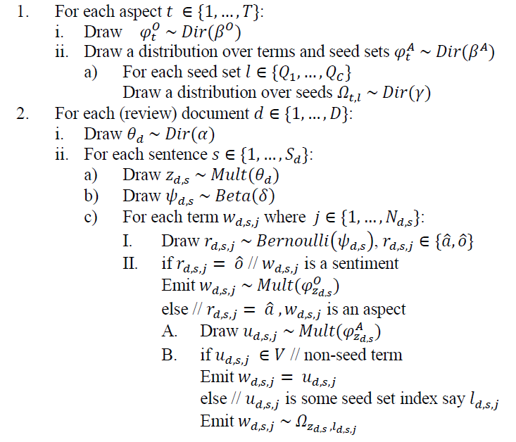

**3.2 ME-SAS Model**

**4 Experiments**

**5 Conclusion**